Project Spy espionage in Kashmir

We recently discovered the use of coronavirus for espionage in Kashmir Region at March 26, 2020. Spyware label is Corona Updates. We had detected these samples as AndroidOS_ProjectSpy.HRX

We find a C2 server: <http://spy.cashnow[.]ee/>

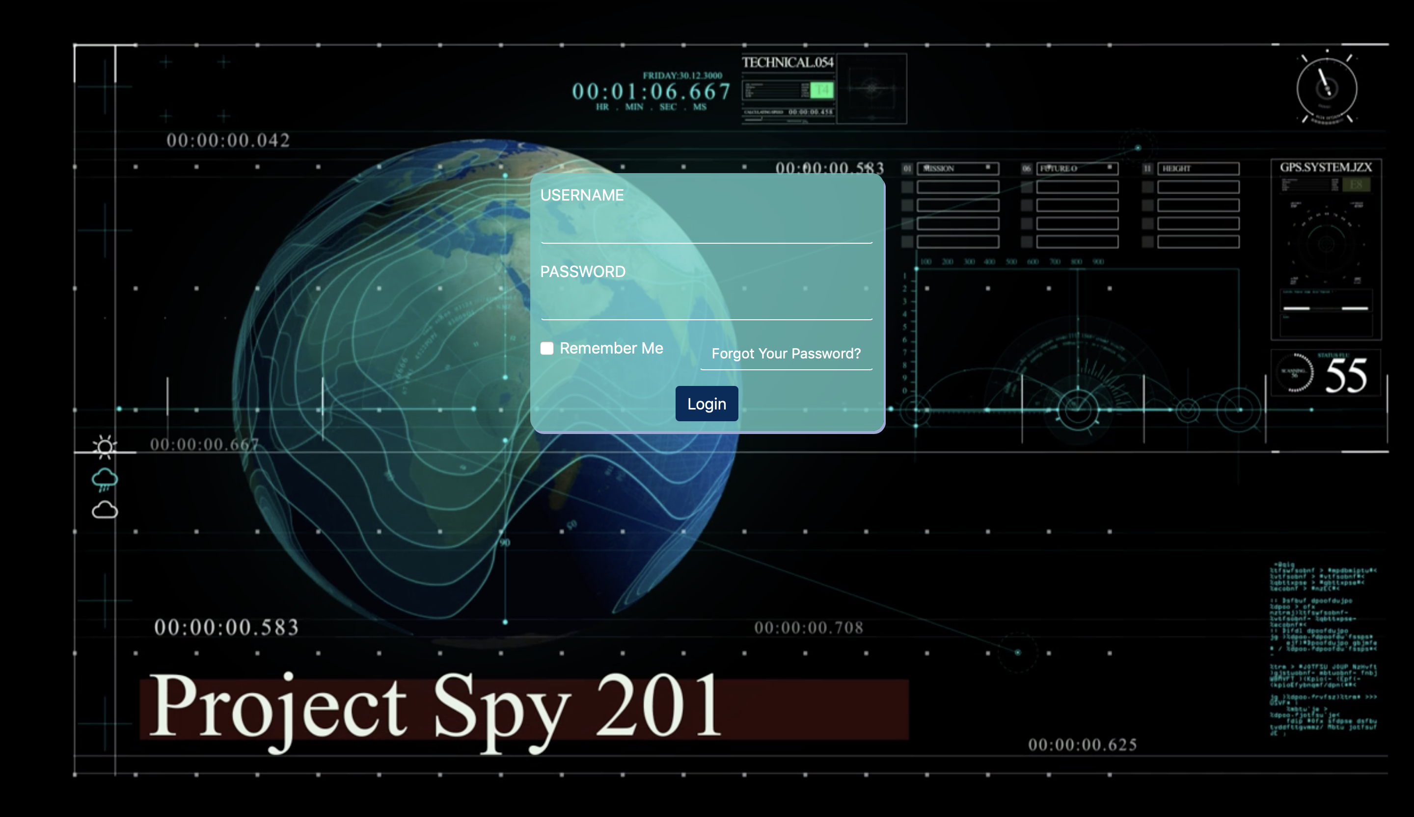

Project Spy campaign timeline as follows:

* first appeared on May 2019
* second appeared on February 2020. First appeared on GooglePlay
* Google remove it from Google Play on March 2020, third appeared on March 26,2020, during corona virus

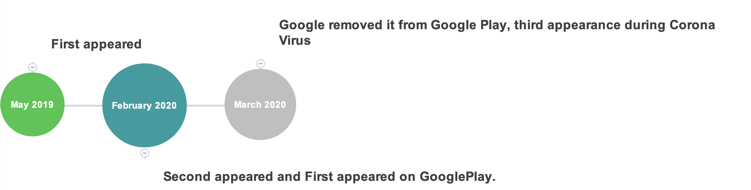

We found the spy campaign first appeared on May 2019.

Sha256: e394e53e53cd9047d6cff184ac333ef7698a34b777ae3aac82c2c669ef661dfe

malicious behavior is as follows:

* Collect Device Info: IMEI, Device_ID, manuature, model, phone number
* Collect SMS
* Send SMS
* Collect Location
* Collect callLog
* Camera capture
* Upload file
* Call and Call State monitor
* Collect contacts

C2 server is cashnow[.]ee

ftp: [ftp.XXXX[.]com](ftp://ftp.XXXX[.]com)

The spy campaign second appeared on February 2020. First appeared on GooglePlay.

Developer is concipit1248.

Sha256: e8d4713e43241ab09d40c2ae8814302f77de76650ccf3e7db83b3ac8ad41f9fa

malicious behavior is as follows:

* Collect Device Info 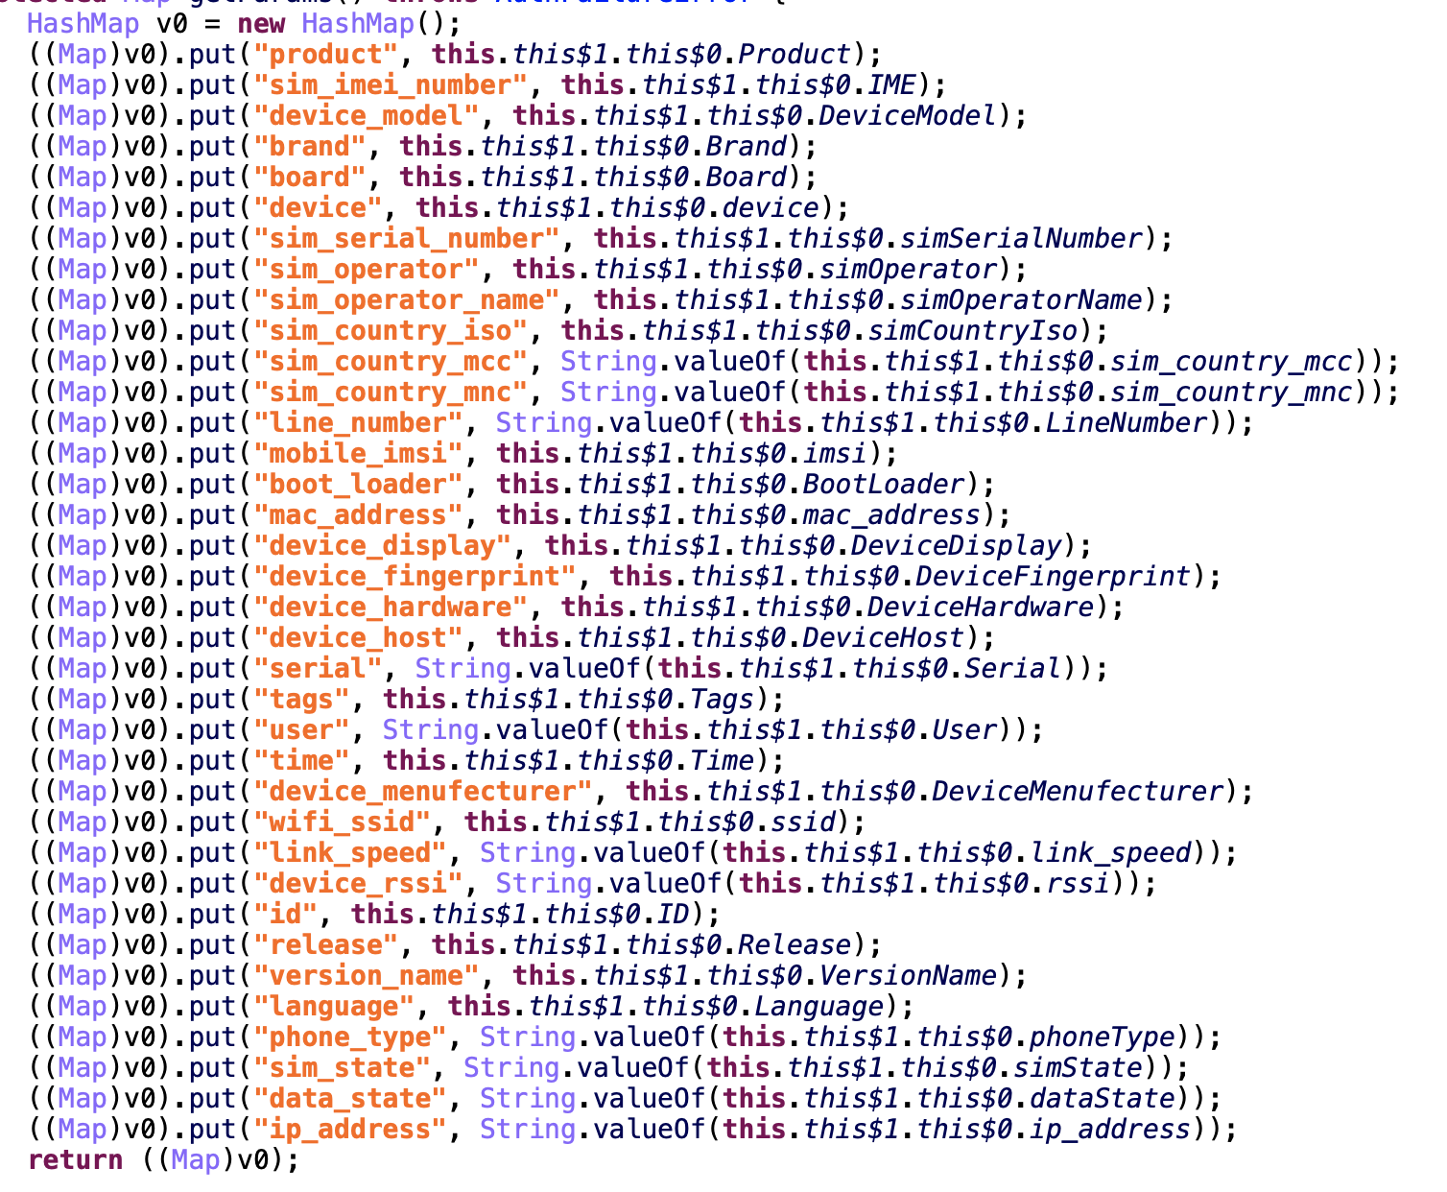
* Upload File: image, audio,text, video
* Steal notification message: whatsapp, facebook and telegram
* Steal SMS
* Send SMS
* Collect location
* Collect contacts
* Collect account

C2 Server:

spy.cashnow[.]ee

xyz.cashnow[.]ee

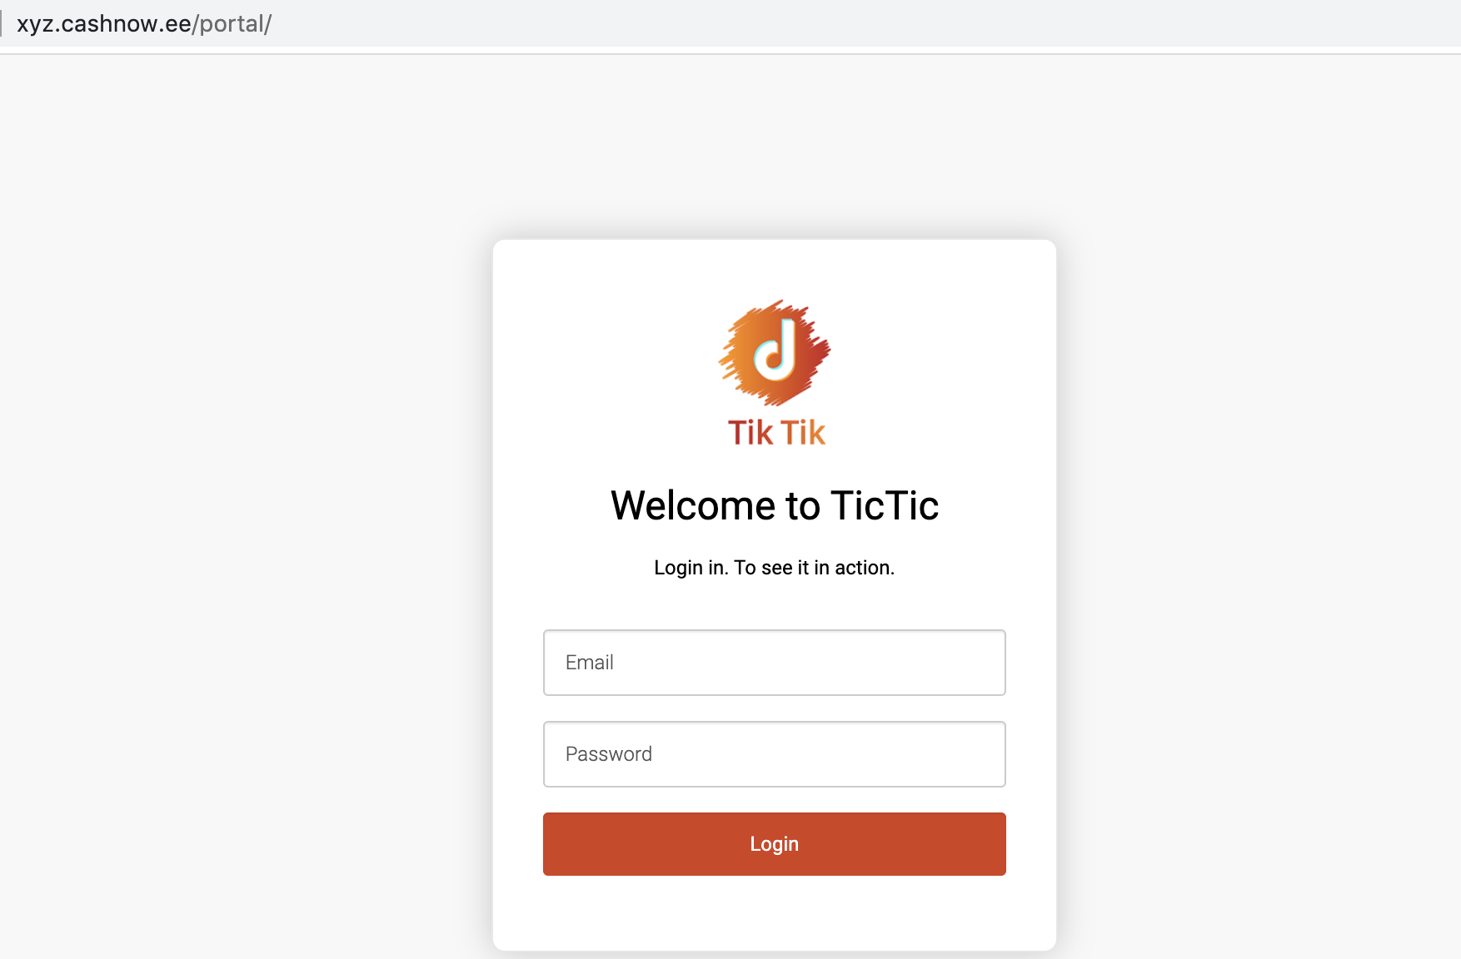

Base on xyz.cashnow[.]ee, we found the spy campaign date between May 12, 2019 and February 24, 2020. Because Google removed it in March 2020.





The third appearance was during coronavirus,date is March 26,2020. It masks itself as a Corona Updates app.

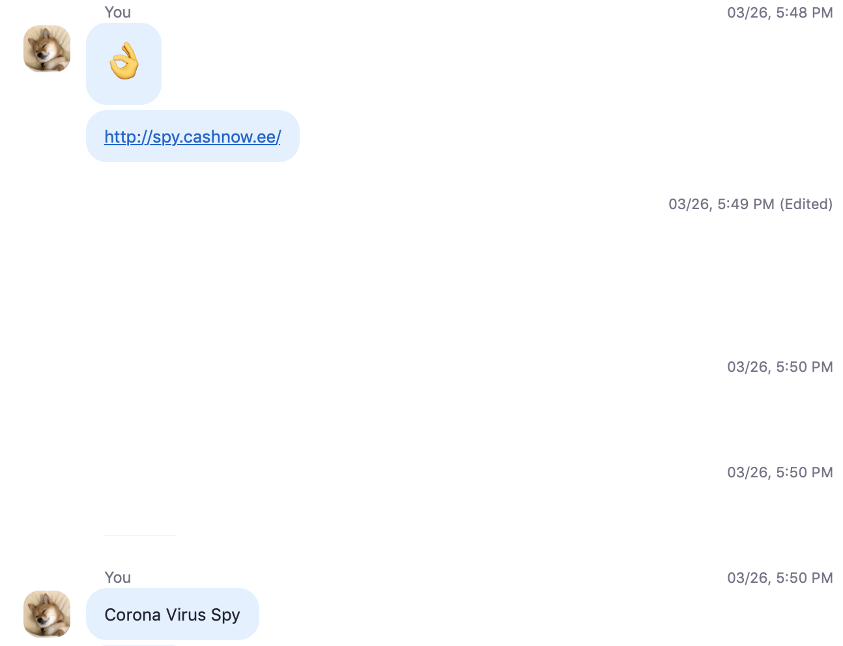

Label: Corona Updates

Sha256: 29b0d86ae68d83f9578c3f36041df943195bc55a7f3f1d45a9c23f145d75af9d

malicious behavior is as follows:

* Upload GSM/WhatsApp/Telegram/Facebook Message

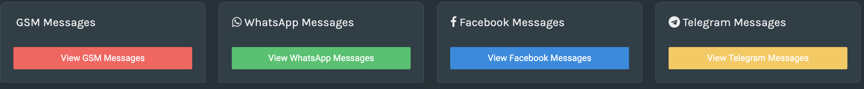

* Upload Device info

|  |  |
| --- | --- |
| IMEI : | Name : |
| Product : | Model : |
| Board : | Brand : |
| Manufacturer: | User : |
| Tag: | Serial : |
| Host : | Hardware : |
| Andriod Version : | Bootloader : |
| Application Version : | Device Ip : |

* Upload Sim info

|  |  |
| --- | --- |
| IMSI : | Sim Serial: |
| Opereator Code : | Operator Name : |
| Country : | Mobile Number : |
| MCC-Mobile Country : |  |

* Upload Wifi info

|  |  |  |
| --- | --- | --- |
| SSId : | Wifi Speed : | MAC Address : |

* Upload Other info

|  |
| --- |
| Display : |
| DateTime : |
| Fingerprint : |
| Created At : |
| Updated At : |

* Upload Voice Note
* Upload Contacts
* Upload Accounts
* Upload Call Logs
* Upload Location
* Upload images

So far, we found a total of 76 devices infected, 8451 WhatsApp Voice Notes, and 158 Telegram Voice Notes

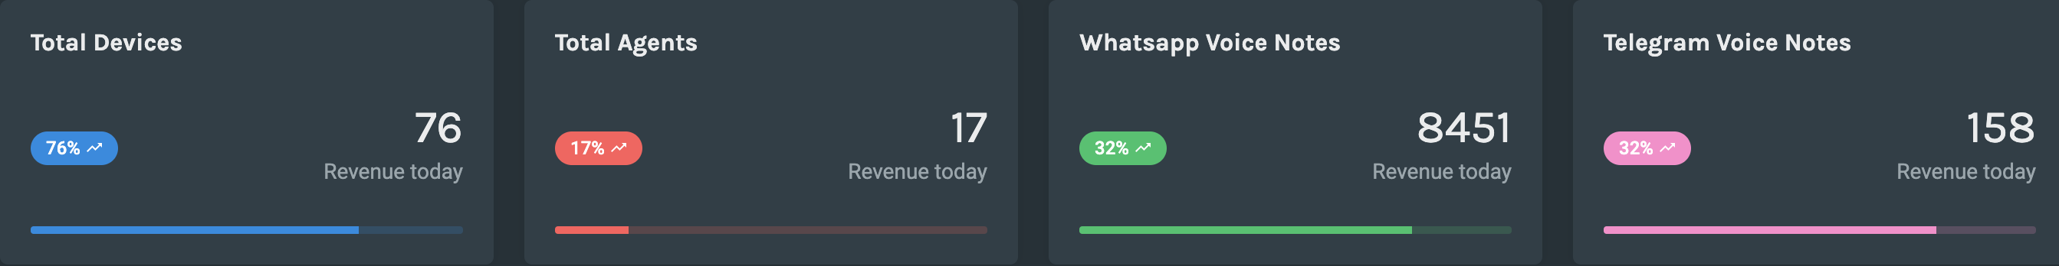

How to steal WhatsApp, Telegram and Facebook message?

* 1. Abuse of notification permission

Send broadcast

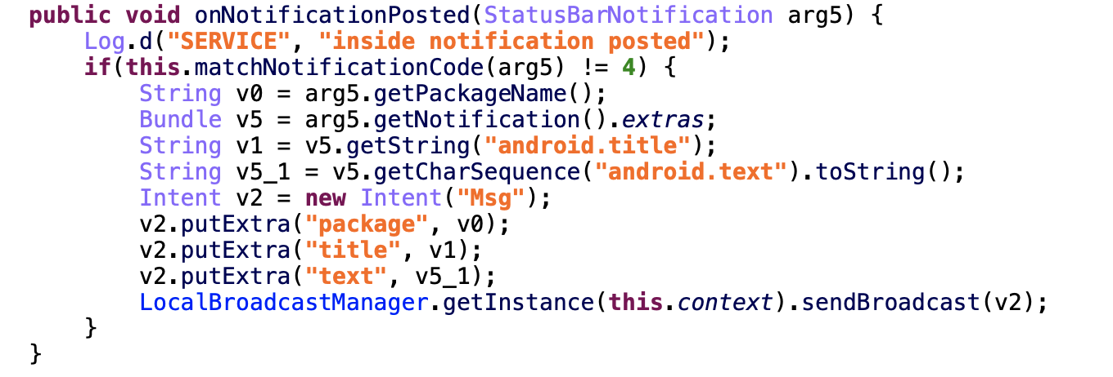

Receive broadcast and save notification content in DB

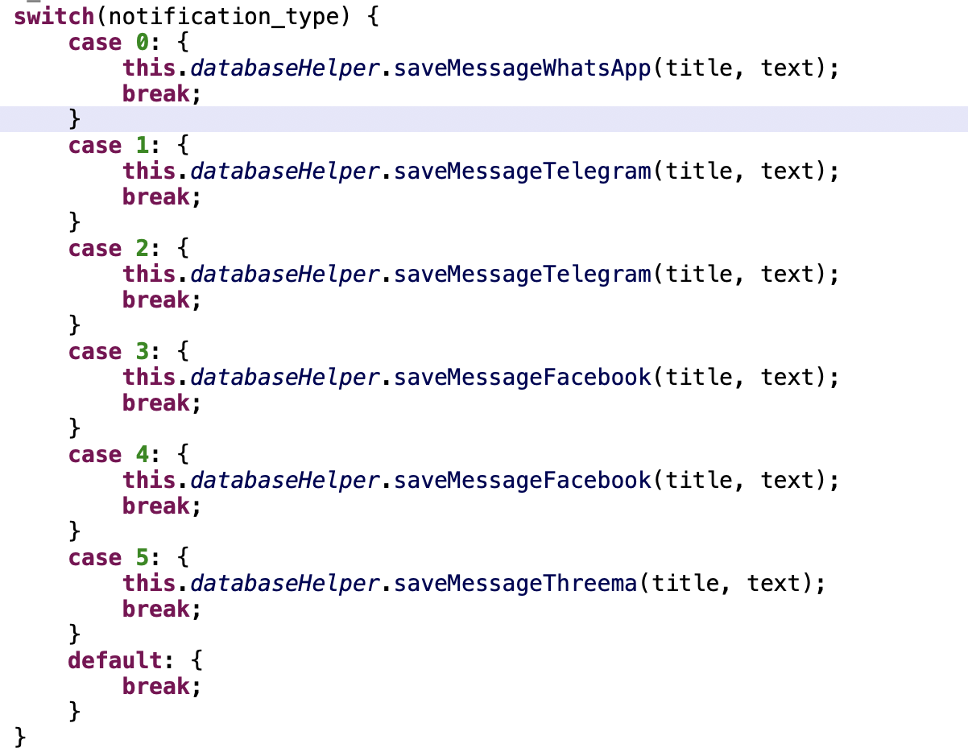

* 2. Abuse reading external storage permission

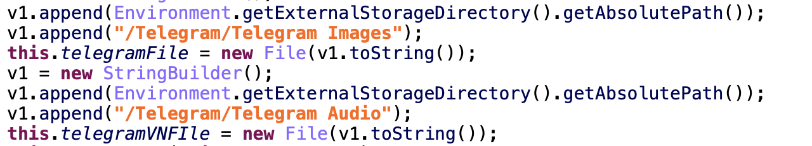

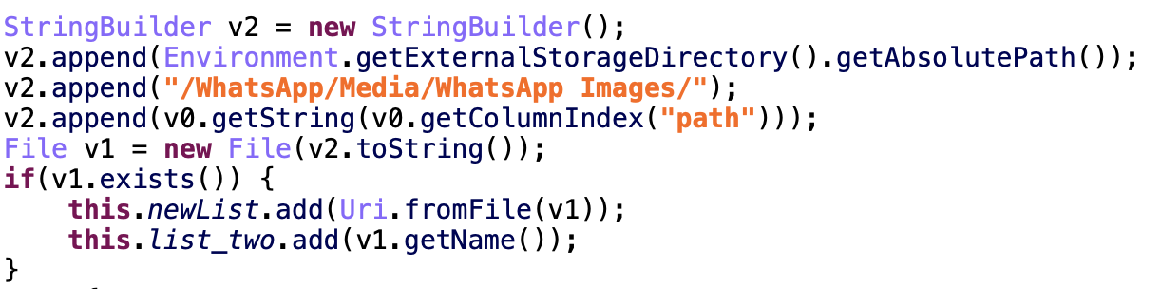

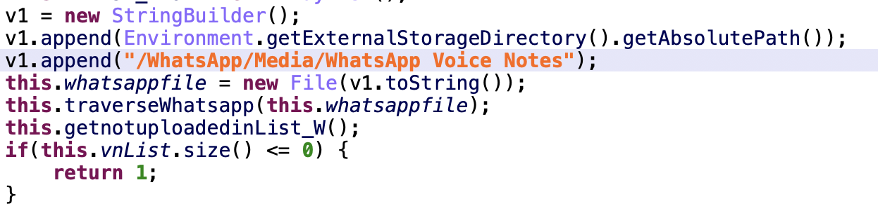

Remove duplicate victim, their nationalities are distributed as follows

|  |  |
| --- | --- |
| India | 11 |
| Bangladesh | 2 |
| Austria | 1 |
| Romania | 1 |
| Grenada | 1 |
| Iran | 2 |
| Afghanistan | 8 |
| Russia | 1 |
| United Arab Emirates | 1 |
| Saudi Arabia | 2 |
| Pakistan | 28 |

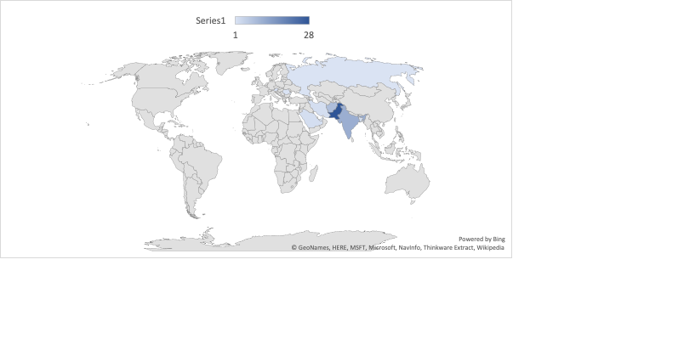

Here are the months and the number of victims, we can see that the number of victims has skyrocketed since the corona virus outbreak.

|  |  |
| --- | --- |
| Dec 2019 | 8 |
| Jan 2020 | 12 |
| Feb 2020 | 6 |
| Mar 2020 | 49 |

We found that more victims were frontier soldiers living on India-Pakistan border.

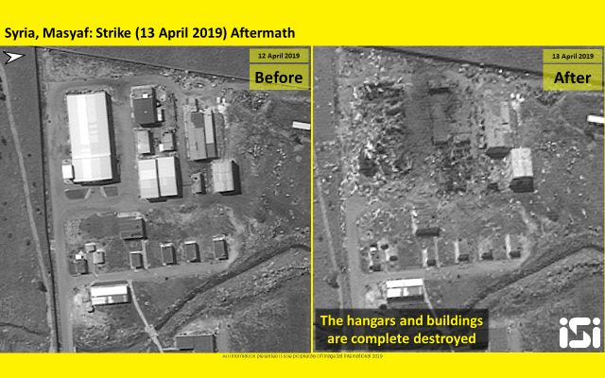

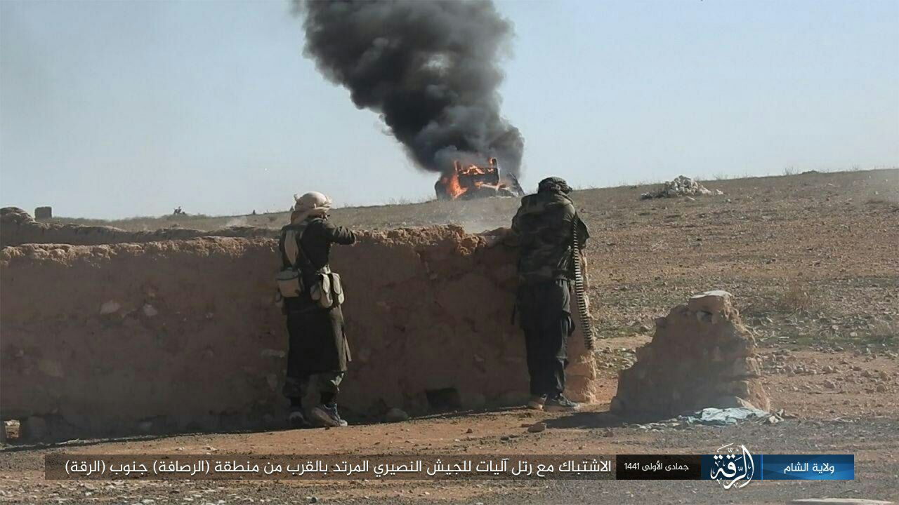

In addition, Project Spy began to switch to the iOS, we found project spy apps in App Store.

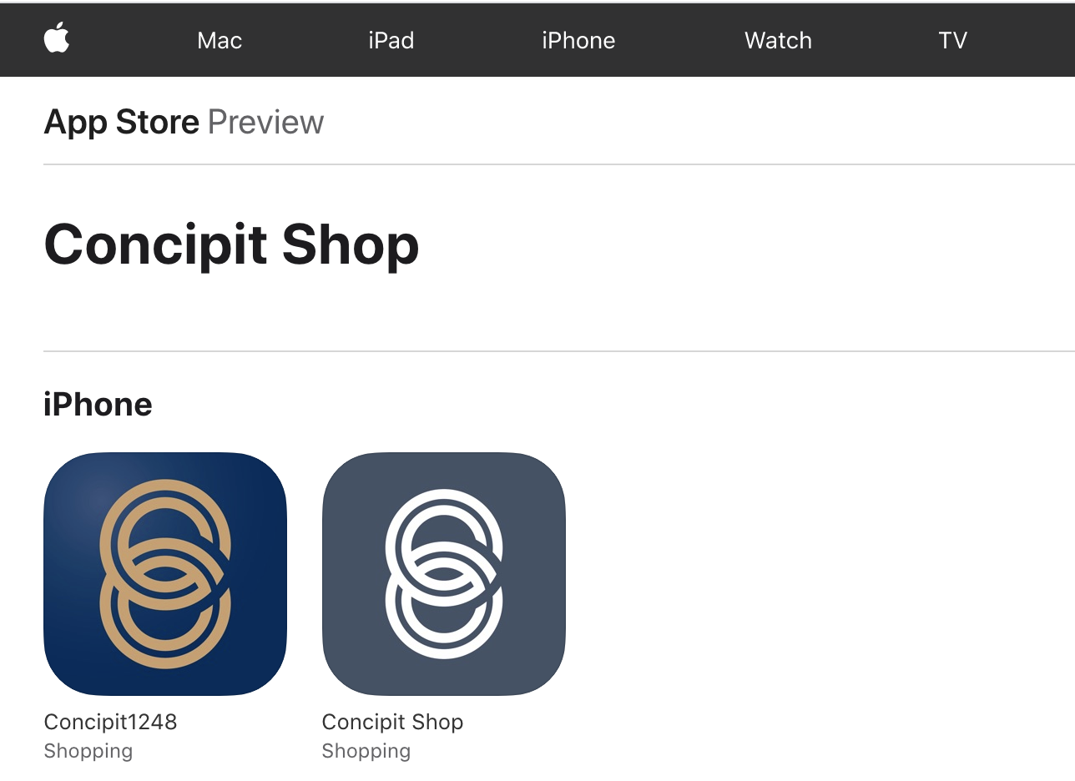

After investigation we found that one of these apps called Concipit1248 had an interesting c2 server spy.cashnow.ee which is already known to be malicious.

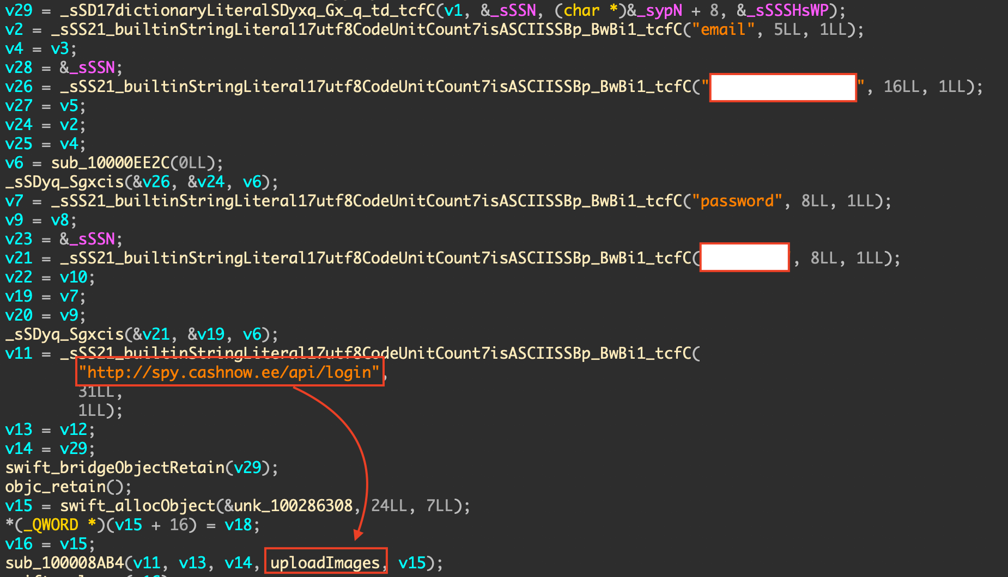

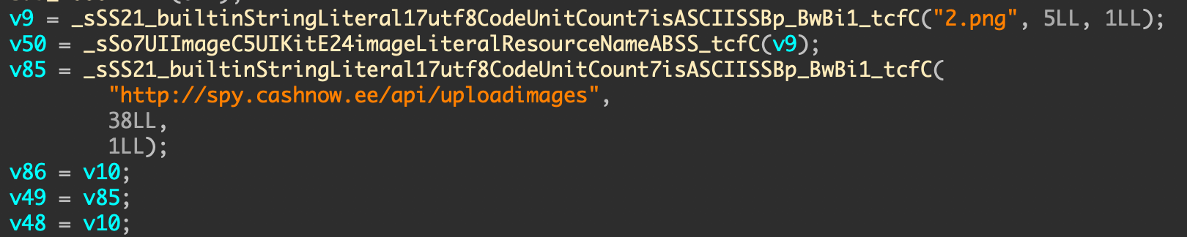

By the analysis we can already infer that this app has been implanted with a backdoor which can be used to steal the photos on victims' iPhone. To verify that assumption, we also checked the permission asked by this application and some related code.

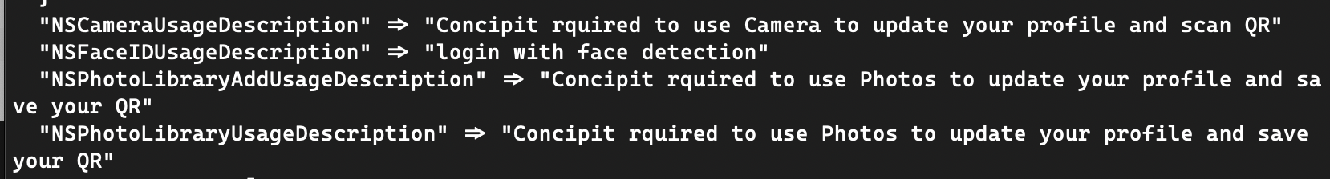

But we did not find any further malicious behavior and the another Concipit Shop App seems to be normal, because the last update time of these two apps is Nov 23, 2019.

Similarly, there are two apps on Google Play, the author's last update time of these two apps is Nov 22, 2019, there two samples also seem to be normal.

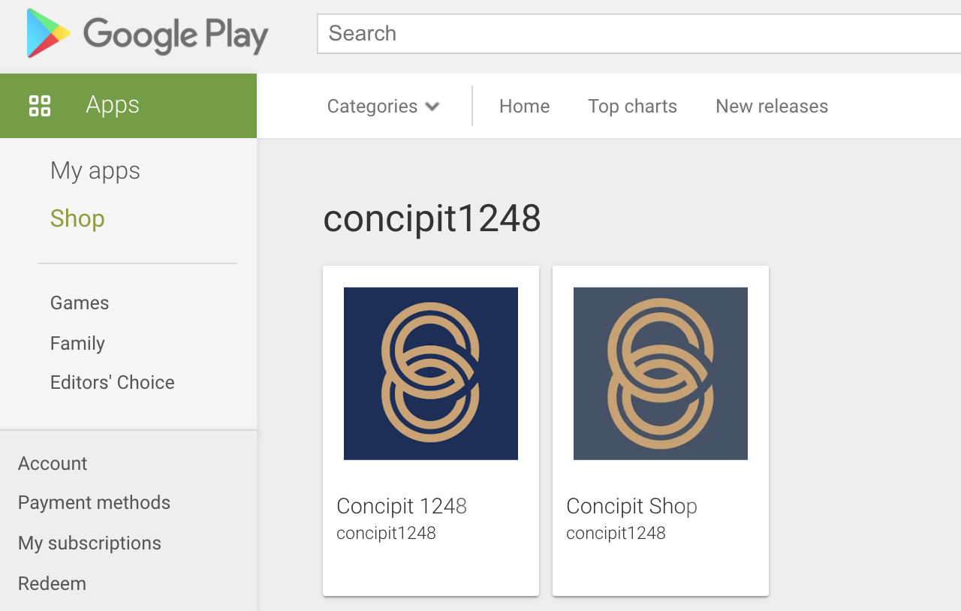

Who did?

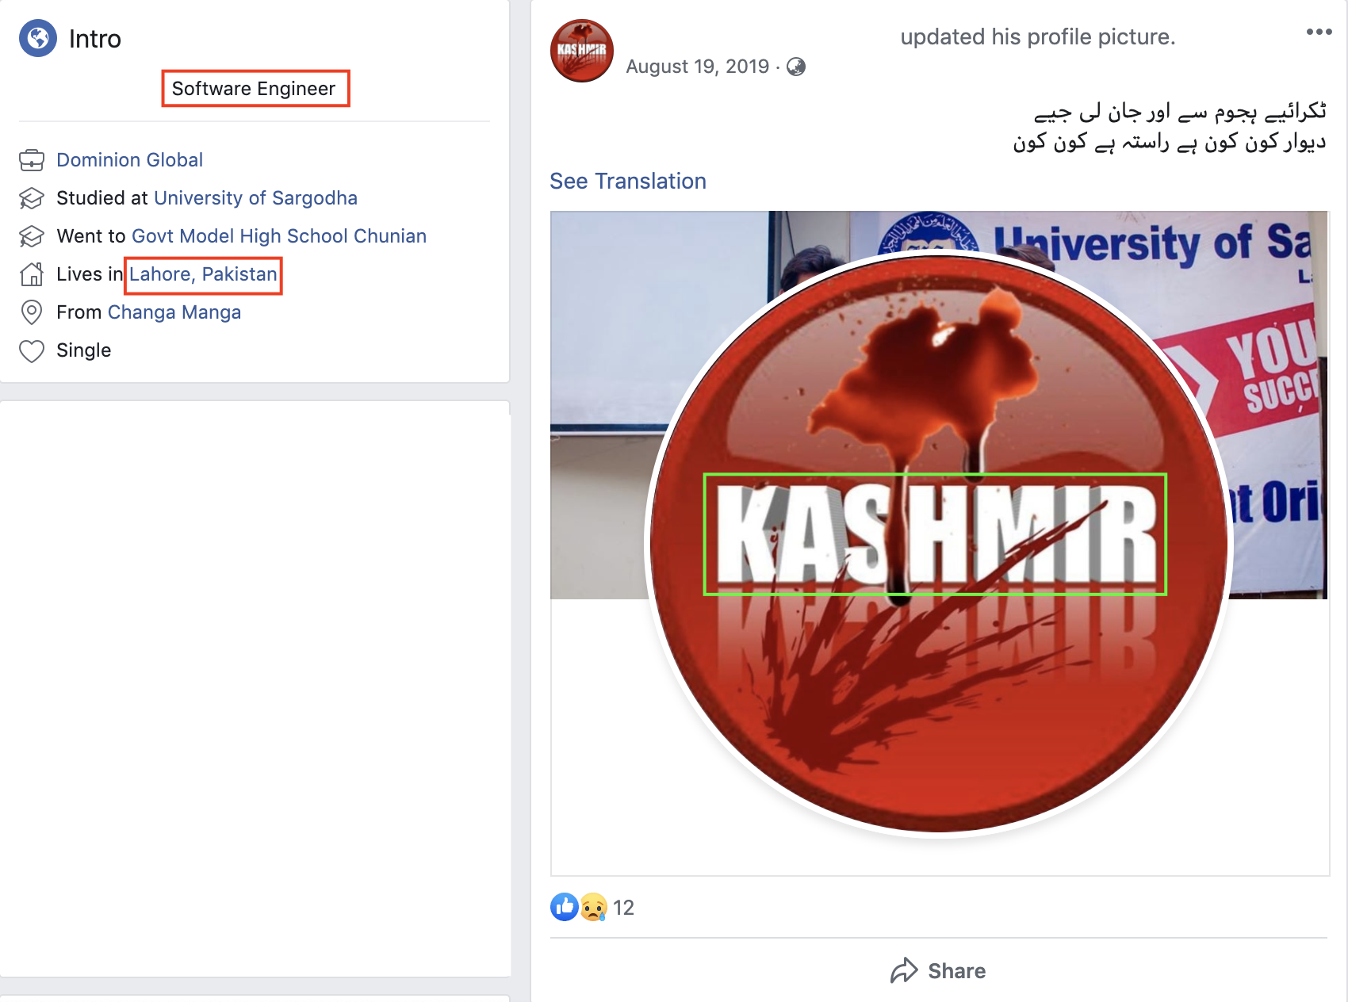 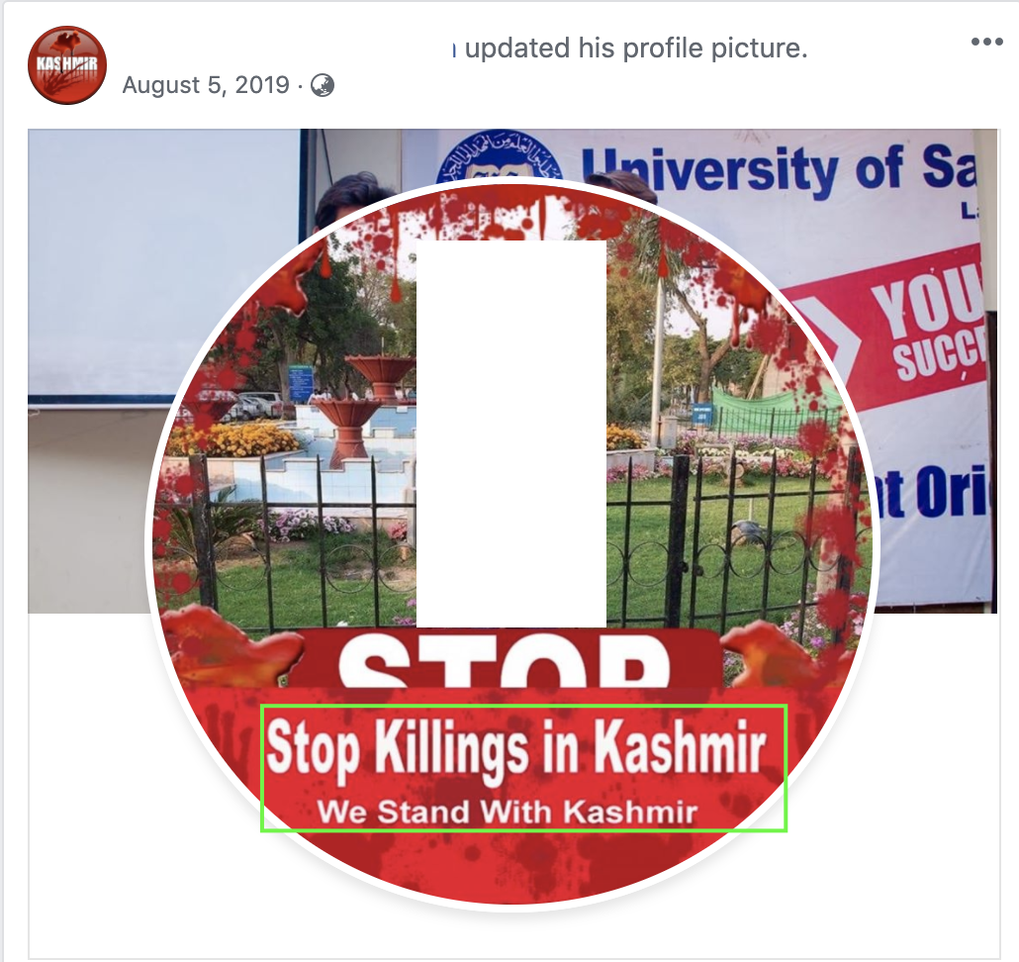

We found more victims' location information is Lahore, Pakistan. And the victims are almost all frontier soldiers. Kashmiri Gate is one of the thirteen gates of Walled City of Lahore in Lahore, Punjab, Pakistan. The gate gets its name as it faces in the direction of Kashmir. The Kashmir conflict is a territorial conflict primarily between India and Pakistan over the Kashmir region.

